**VECTR v6.1.0 Feature Breakdown**

Table of Contents

Advanced Reporting Filters 2

GraphQL Read-Only API Access 6

# Advanced Reporting Filters

What is it?

VECTR now supports reporting filters by custom tags at the Assessment, Campaign, and Test Case level.

How does it work?

For Assessments and Campaigns, select the corresponding tagging icon next to the selection dropdown. This will populate the dropdown with included and excluded tag criteria for selection.

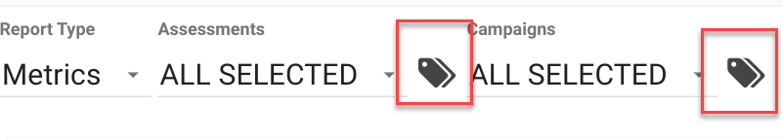

For example, let’s assume you had tags for each year for your Assessments:  
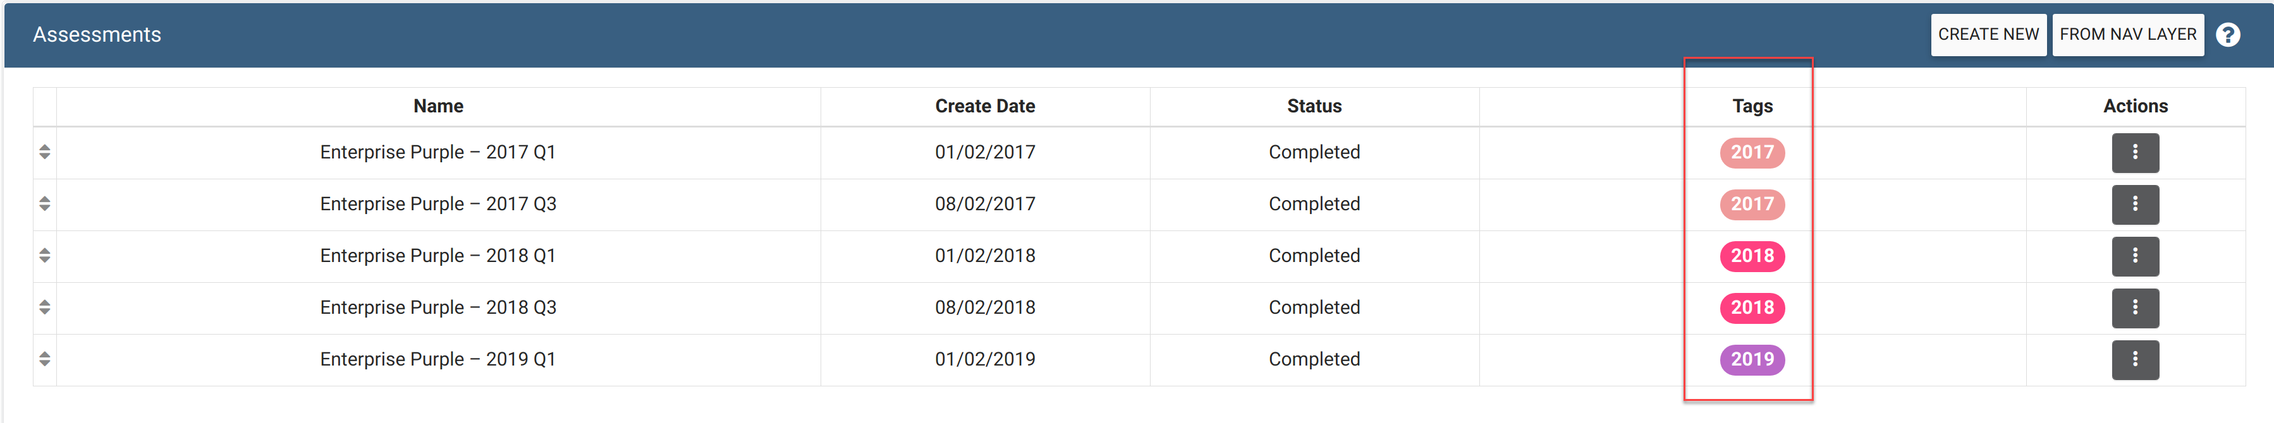

If you wanted to see all Assessments tagged with 2018:

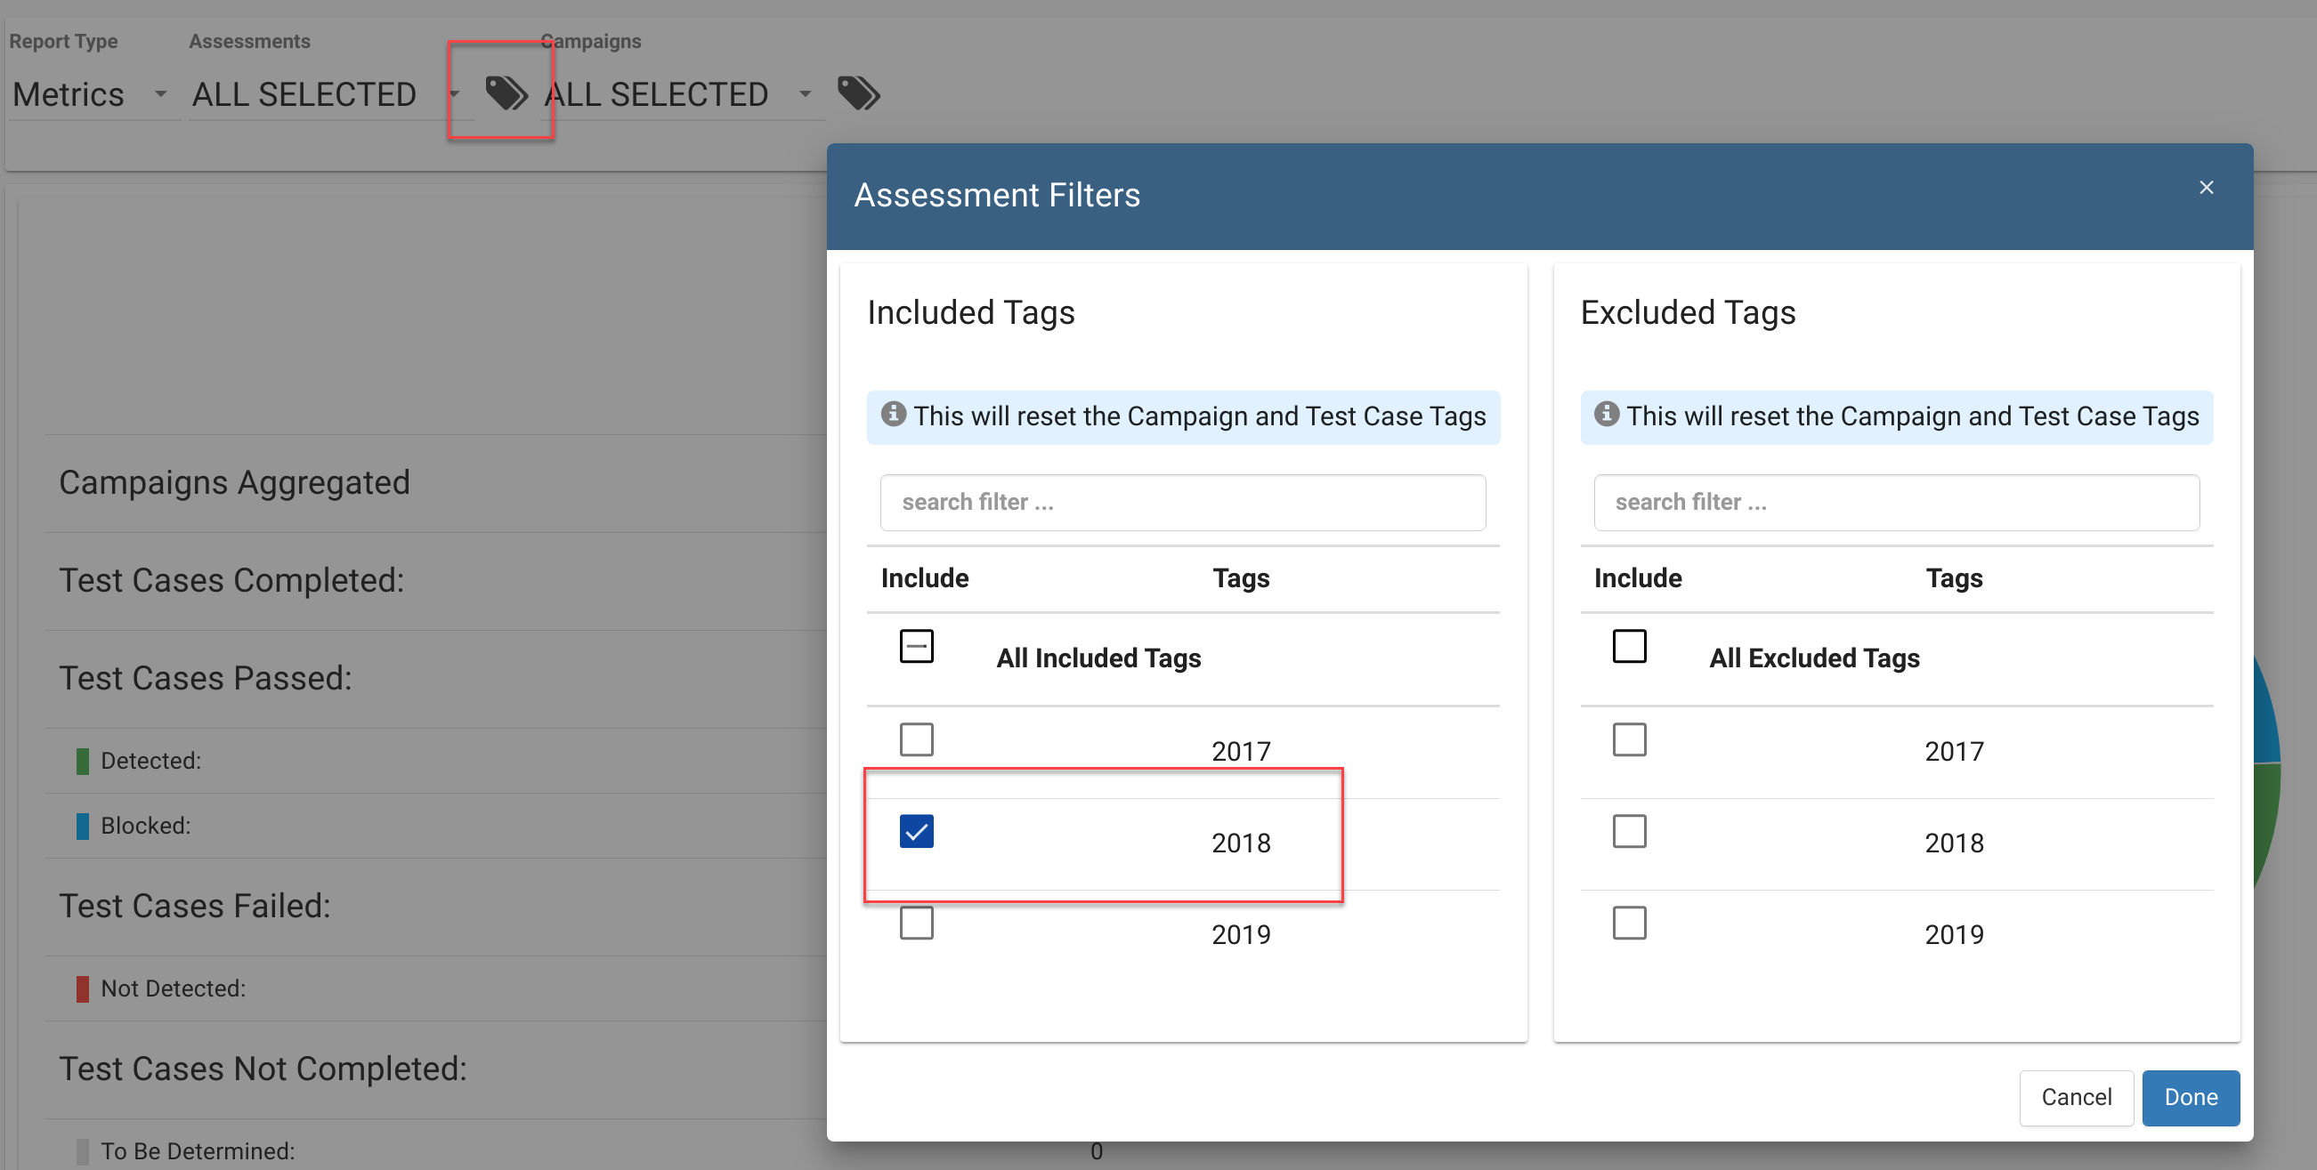

This will show only the relevant items in the dropdown for “2018”, pre-selected, along with updated calculations throughout all the reporting screens for the applied Assessment level tag filters:

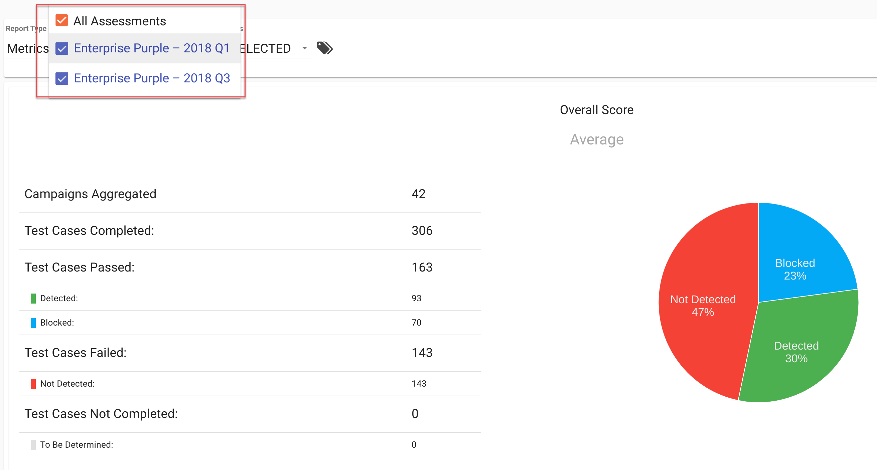

It is also possible to select everything NOT tagged with “2018”:

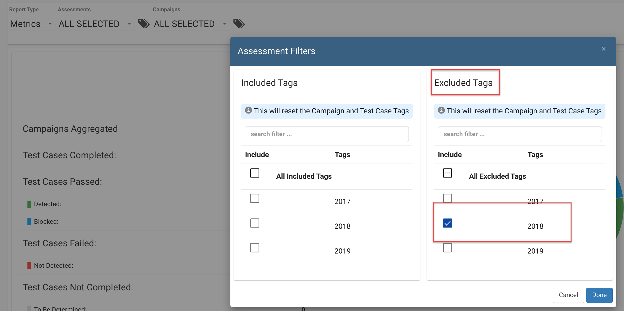

This filter will show only the non-2018 Assessments in the dropdown pre-selected, along with updated calculations for the selected data sets:

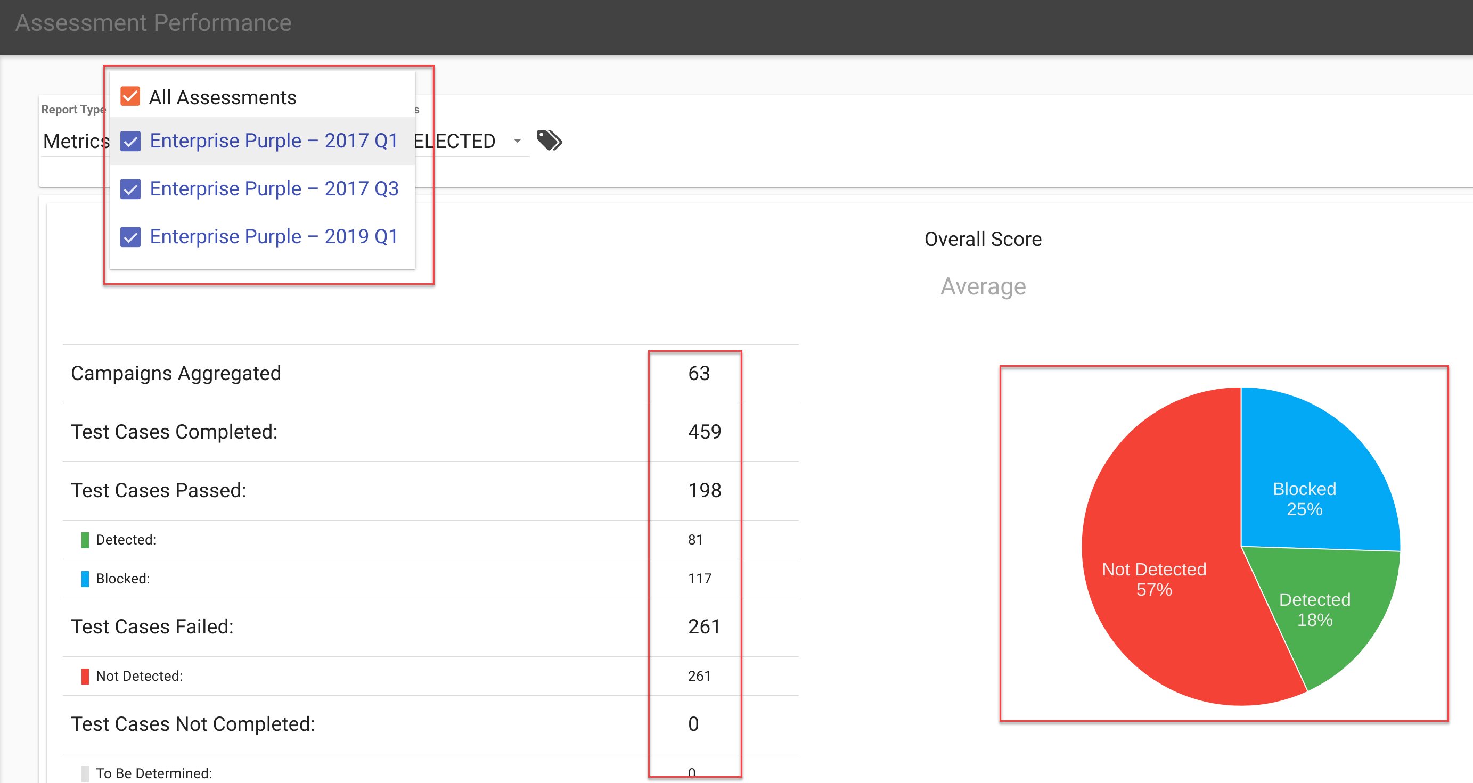

To see all applied filters, you can click in the top right corner to expand and collapse the advanced filters panel:

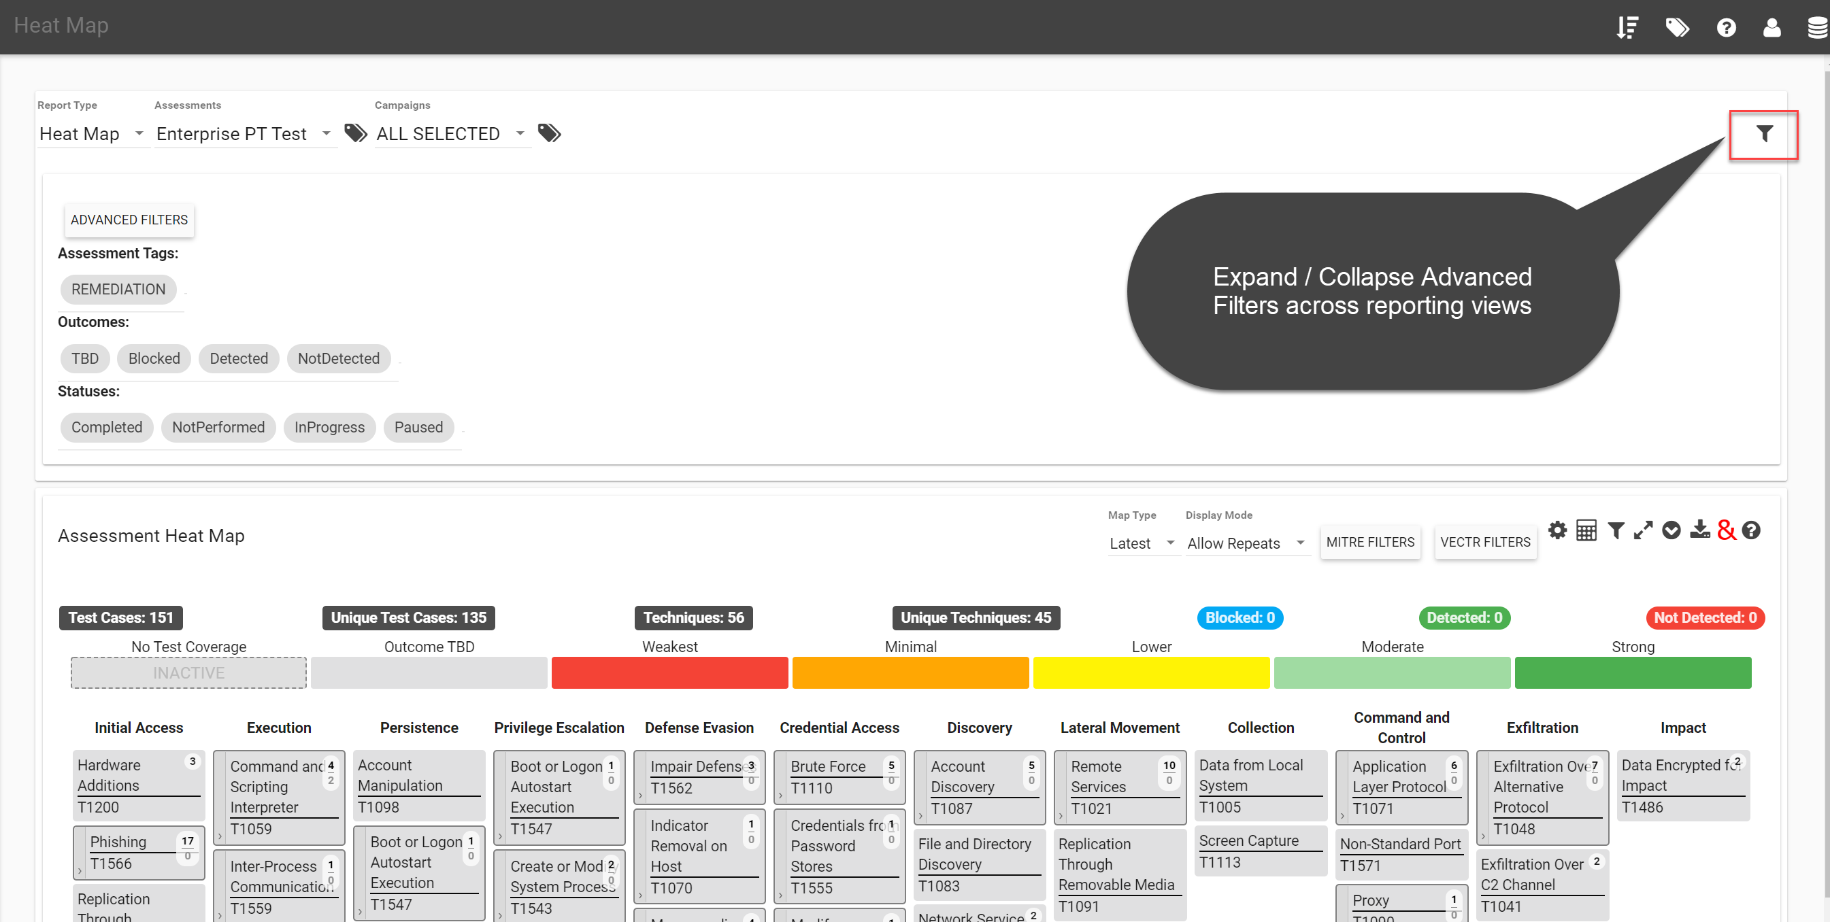

The Advanced Filters button allows advanced filtering of results based on Test Case level Tagging, Status, and Outcome. In this example only test cases with tag values of “PRIORITY” or “QUEUED FOR ANALYSIS” will be returned:

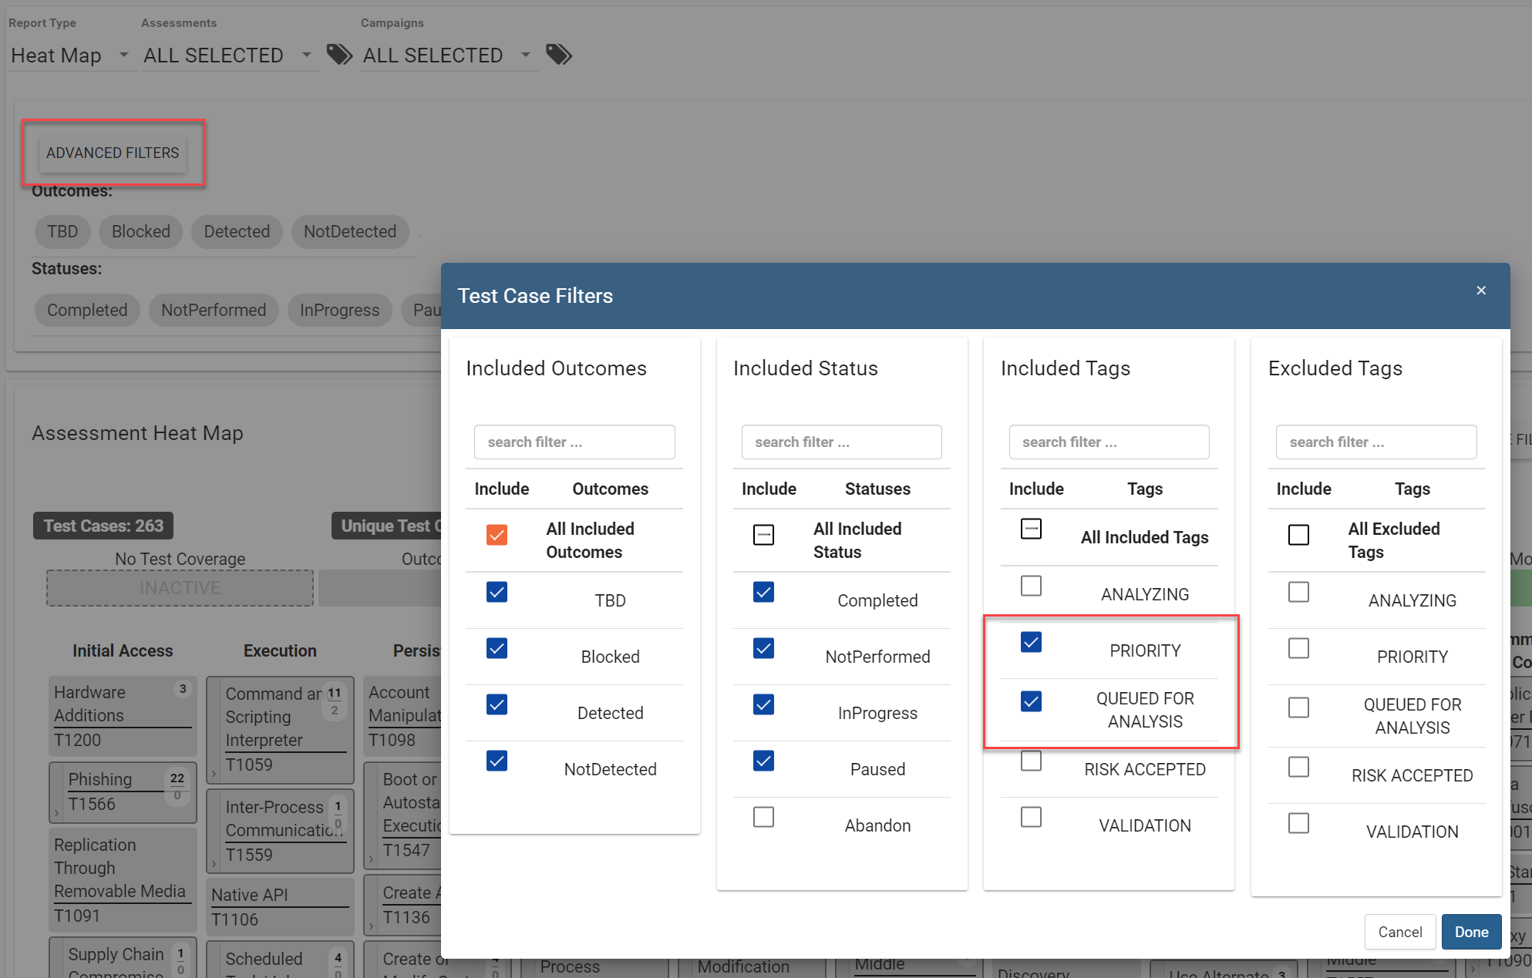

How can this feature help me?

This will allow users to allow more granular control on reporting based on an organization’s tagging scheme.

# GraphQL Read-Only API Access

What is it?

VECTR now supports GraphQL read-only API access.

How does it work?

There is documentation available on the docs.vectr.io website, including Overview and Schema Reference:  
<https://docs.vectr.io/GraphQL-API/>

How can this feature help me?

This will allow users to query for data from outside the VECTR application.

